DISC Pulse Secure Setup Instructions for Remote Access

Open Pulse Secure App
Click on + symbol in Connections
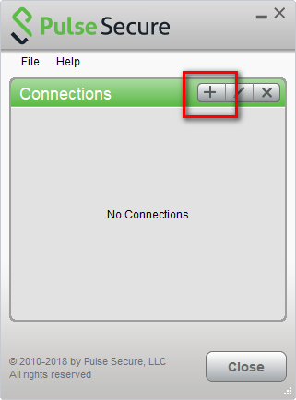
Enter the following:
Name: DISC
Server URL: nag.edc.usda.gov/lincpass
Click Add
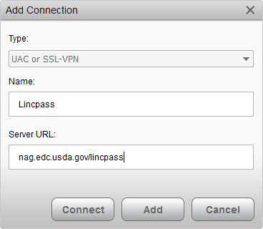

Click Connect
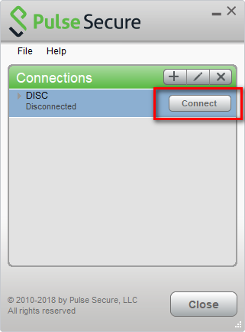
Select the “Authentication” certificate on the Lincpass card, save settings, then click connect
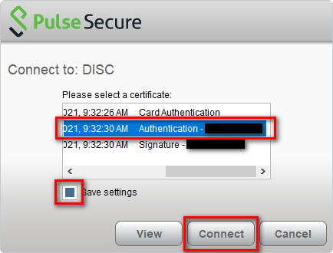

Enter Pin then select OK
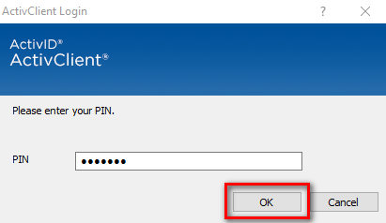
Accept End User Agreement
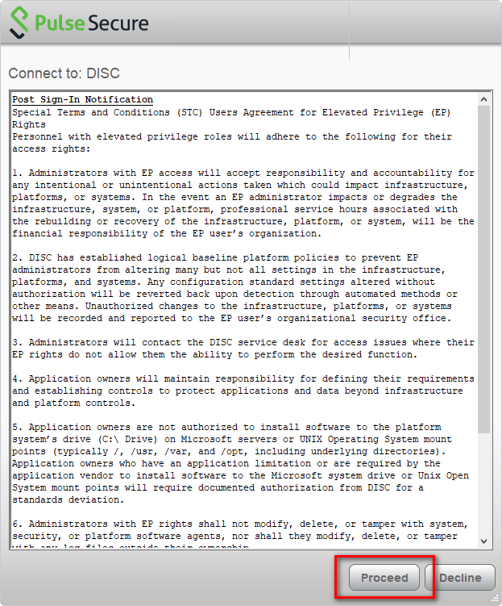

Confirm you are connected and then select close.
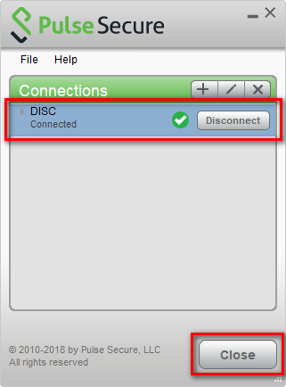
The VPN connection will remain open as indicated on your taskbar

